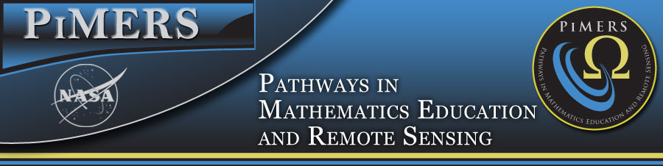

To: PiMERS Summer Middle School Researchers and Parents
From: Dr. Darnell Johnson, Program Coordinator
Date: June 2, 2016

Congratulations, your child has been chosen from a pool of twenty-five candidates applying for the PiMERS Middle School Program. Students are expected to report to room 232 in Dixon Hall on Monday, June 13, 2016
at 10:00am with at least one parent or guardian on the campus of Elizabeth City State University. Parents must
arrange transportation to and from the campus on a daily basis.

We look forward to working with each student this summer. The schedule for the program is below. Students
can use the open lab periods to complete required assignments or prepare for the next day. Students will receive
a stipend of $100.00 (after the completion of task sheet assignments) on the last day of the program.

Please call 335-3696 or email me at djohnson@cerser.ecsu.edu should you have questions regarding this program.

 | 10am - noon | Noon – 1pm |  | 1pm – 3pm
All Students should report to 232 Dixon Hall on the Campus of ECSU each day.
Mon. June 13 | Program Opening  Dr. Linda Hayden | Lunch Seminar:  Remote Sensing with Satellites  Andrew Brumfield |  | Digital Camera Training  Jeff Wood (Lab)
Tues. June 14 | PowerPoint Training  Jeff Wood (Lab) | Lunch Seminar:  UAVs  Cornelius Holness |  | Math Application Session I  Math Team
Wed. June 15 | Visit to VASC in Hampton, VA |  |  | VASC IMAX
Thurs. June 16 | Hydrology Training  Pharmacy Building  Sheryl Bradford | Lunch Seminar:  Computer Science  Derek Morris |  | Hydrology Training  Pharmacy Building  Sheryl Bradford
Friday June 17 | Math Application Session II  Math Team | Lunch Seminar:  Aviation & Robotics  Orestes Gooden |  | Visit STEM Lab  in Dixon Hall  Orestes Gooden
Mon. June 20 | GPS Training  Cornelius Holness  Graduate Student | Lunch Seminar:  Networking  Kevin Benton |  | Campus Technology Tour  Dr. Darnell Johnson
Tues. June 21 | Visit ECPI University Research Lab in Virginia Beach, VA
Wed. June 22 | Robotics with Legos I  Math Team (Lab) | Lunch Seminar:  CERSER Student  Kamberlin King |  | Robotics with Legos II  Math Team (Lab)
Thurs. June 23 | Robotics with Legos III  (Math Team Lab) | Lunch Seminar:  Networking  Daquan Roscoe |  | Robotics Competition  Math Team (Lab)
Fri. June 24 | Open Lab  Task Sheets Due | Closing Program and Luncheon Dr. Linda Hayden

Program Staff
Principal Investigator: Dr. Linda Hayden, Principal Investigator, CERSER
Program Coordinators: Dr. Darnell Johnson, PiMERS Coordinator
Camera/Power Point Trainer: Jeff Wood, CERSER Webmaster
GPS Trainer: Cornelius Holness, Graduate Student-CERSER
Hydrology Trainer: Sheryl Bradford, ECSU Safety Coordinator
Robotics Facilitators: Derek Morris & Steffi Walthall-(Math Team)
Administrative Assistants: Joal Hathaway & Steffi Walthall

Seminar Guest Speakers
ECSU Graduate & Undergraduate CERSER Students
Orestes Gooden, Assistant Professor for Aviation Science
Ryan Lawrence, PhD student, University of New Hampshire

